

JOIN THE 27TH ANNUAL
DUPAGE COUNTY CELEBRATION
THE LIFE, LEGACY, AND VISION
OF DR. MARTIN LUTHER KING, JR.

CALLED TOGETHER BY GOD’S SPIRIT
Crossing Traditional Gender And Generational Lines

MONDAY, JANUARY 16, 2017
6:30 PM

SAVE THE DATE!
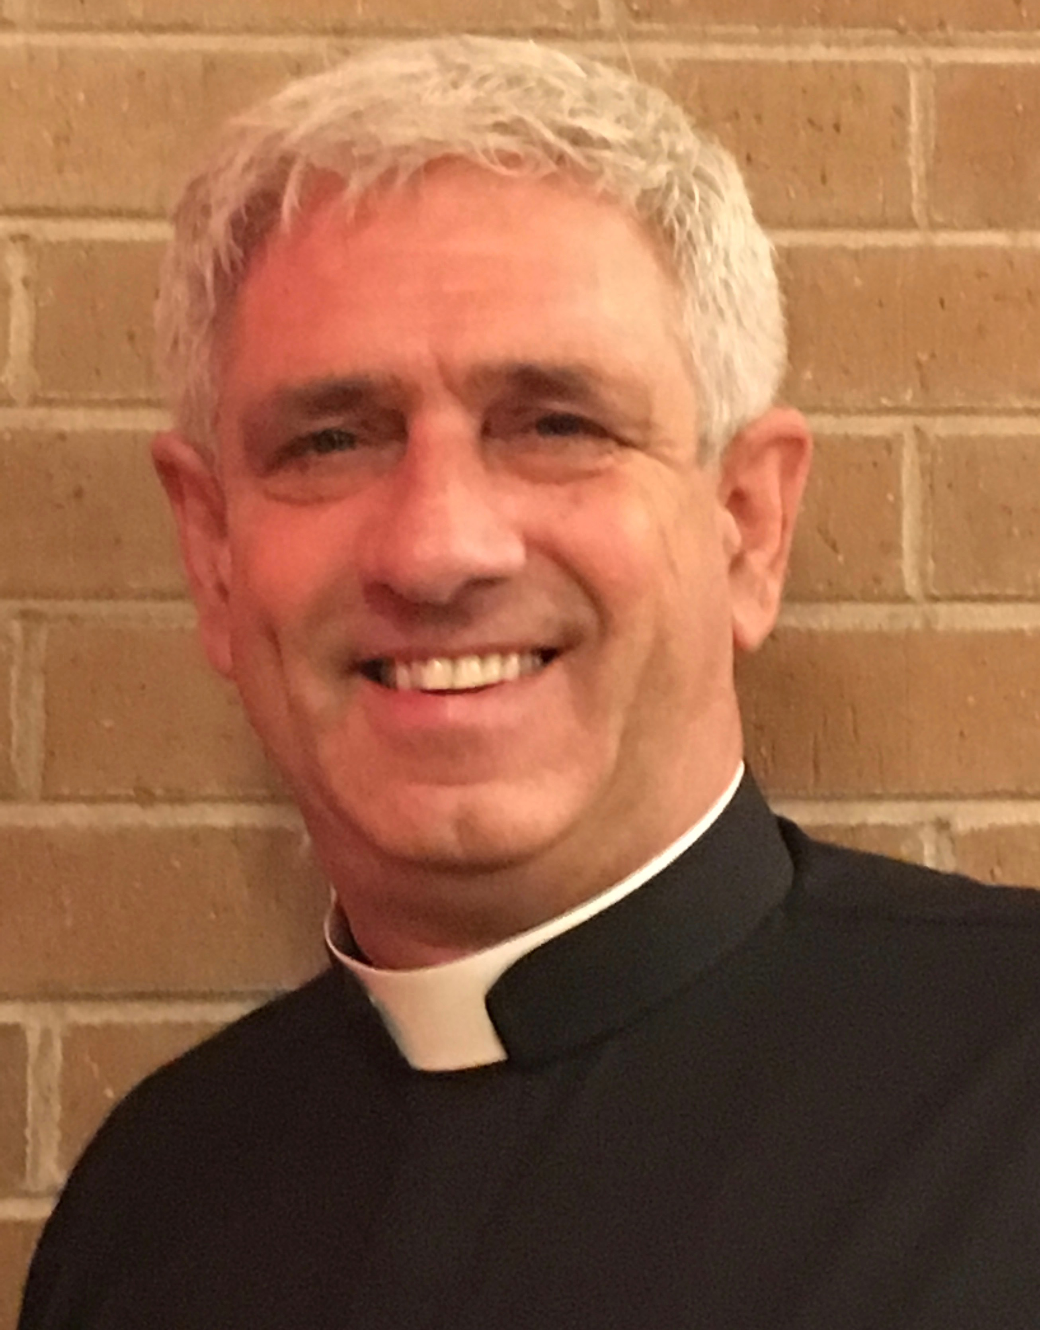
KEYNOTE SPEAKER:
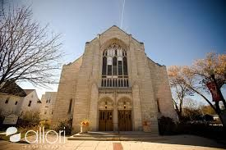
Rev. Jim Honig

Senior Pastor and Author
District Superintendent,
Faith Evangelical Lutheran Church
Glen Ellyn, Illinois 60137
Rev. Honig Is Active On The Local And National
Level In Community Organizing.

All residents of DuPage County are encouraged to join their neighbors who are “Living The Dream” at the Annual Celebration of Dr. Martin Luther King, Jr. at 6:30 p.m., Monday, January 16, 2017 at Gary United Methodist, 224 North Main Street in Wheaton. Come see DuPage County high school students receive scholarship as they advance towards their dreams and goals. A magnificent word of encouragement will also go forth to the DuPage County communities who will attend.

The Annual Event welcomes people of all races, faith traditions, ethnic backgrounds, and economic classes, along with public, educational, business and religious leaders, to celebrate the life and legacy of Dr. Martin Luther Kings, Jr. on this national holiday.

The arc of the moral universe is long, but bends towards justice.
Rev. Dr. Martin Luther King, Jr.

